
Request for Proposal (RFP)
For: Eurovision 2023 research: understanding the role of Eurovision in developing shared values, mutual relationships during a time of conflict, and soft power enabled impacts.
Date: February 2023
1 Overview of the British Council
We support peace and prosperity by building connections, understanding and trust between people in the UK and countries worldwide.
We uniquely combine the UK’s deep expertise in arts and culture, education and the English language, our global presence and relationships in over 100 countries, our unparalleled access to young people and influencers and our creative sparkle.
We work directly with individuals to help them gain the skills, confidence and connections to transform their lives and shape a better world in partnership with the UK. We support them to build networks and explore creative ideas, to learn English, to get a high-quality education and to gain internationally recognised qualifications.
We work with governments and our partners in the education, English language and cultural sectors, in the UK and globally. Working together we make a bigger difference, creating benefit for millions of people all over the world.
We work with people in over 200 countries and territories and are on the ground in more than 100 countries. In 2021–22 we reached 650 million people.
2 Introduction and Background to the Project / Programme
2.1 The purpose and scope of this RFP and supporting documents is to explain in further detail the requirements of the British Council and the process for submitting a proposal in response to this RFP (“Proposal”).
About Eurovision
The Eurovision Song Contest (ESC) is notable for bringing different nations together through music. Eurovision 2023 is a significant moment in time between the UK, Ukraine and Liverpool on an international stage.
Eurovision 2023 will take place in Liverpool over a period from approximately 5 – 13 May 2023. The main activities will be:
- Ticketed rehearsals, semi-finals and the final held at ACCL – 9 shows.
- Fan Park at Pier Head for up to 25,000 people, serving food, drink and showing screenings and music (nightly);
- One-off event ticketed (free) on 7th May for c.20,000 people.
- Various spin off activities, led by hospitality, commercial and cultural organisations themed around Eurovision.
- Cultural commissions.
- Community and education programme through LCR.
- Volunteering programme for up to 500 people.

The purpose of this research commission centres around two research questions / areas of interest:
- Eurovision as a vehicle to developing shared values, mutual relationships during a time of conflict, developing a better understanding Eurovision’s role (or not) in crystalising shared values and/or coalescing around shared values across Europe? And its role in establishing or strengthening relationships in Europe at a time of conflict, based on mutual values and interests.

- Explore the role and impact of Eurovision within City Branding and Soft Power. Investigate how Eurovision supports host cities and nations international brand or soft power (as seen by broad populations, influencers and/or leaders in Europe and beyond). To explore whether Eurovision gives European nations, and cities, such as Liverpool, a reputation uplift based on the values/characteristics it embodies/showcases each year within the Europe region.
Definitions of cultural relations and soft power
Cultural relations are understood as reciprocal transnational interactions between two or more cultures, encompassing a range of activities conducted by state and/or non-state actors within the space of culture and civil society. The overall outcomes of cultural relations are greater connectivity, better mutual understanding, more and deeper relationships, mutually beneficial transactions and enhanced sustainable dialogue between people and cultures, shaped through engagement and attraction rather than coercion. Engagement with UK Arts and cultural output creates a virtuous circle catalysing a desire for further engagement and supports an increase in connections and relationships between cultural sector players in the UK and internationally.
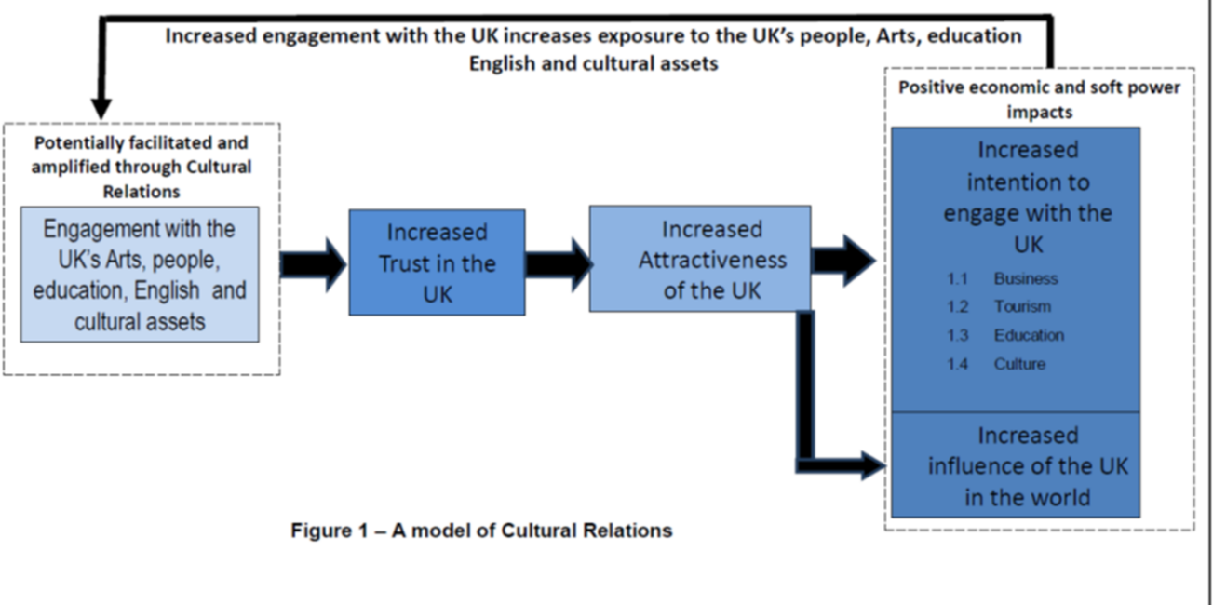

How does Cultural Relations work?
- By delivering positive outcomes for individuals and institutions
- By delivering those outcomes in a way which exemplifies values which are attractive (Cultural Relations)
- By delivering positive outcomes in a way which demonstrate to influential stakeholders that the UK values a relationship with their country.
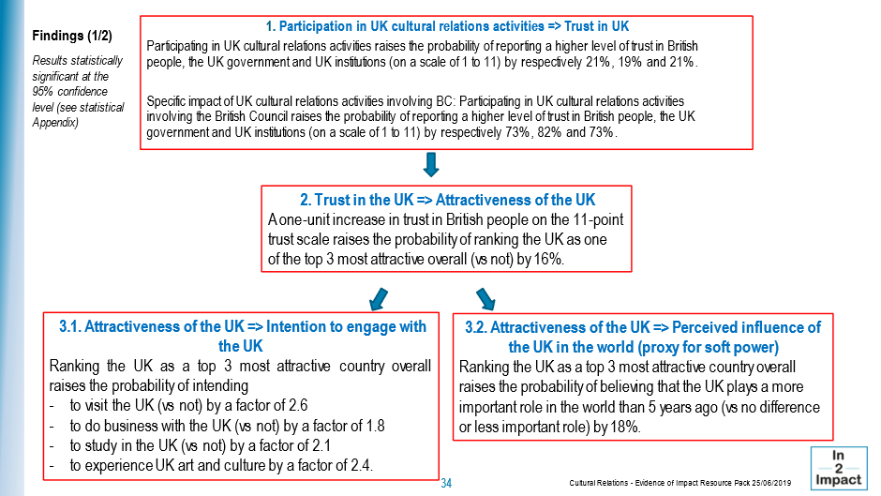
Data from the British Council G20 Survey in 2021 highlights some of the potential impacts of engaging with the UK through a cultural programme with young people across the G20:- 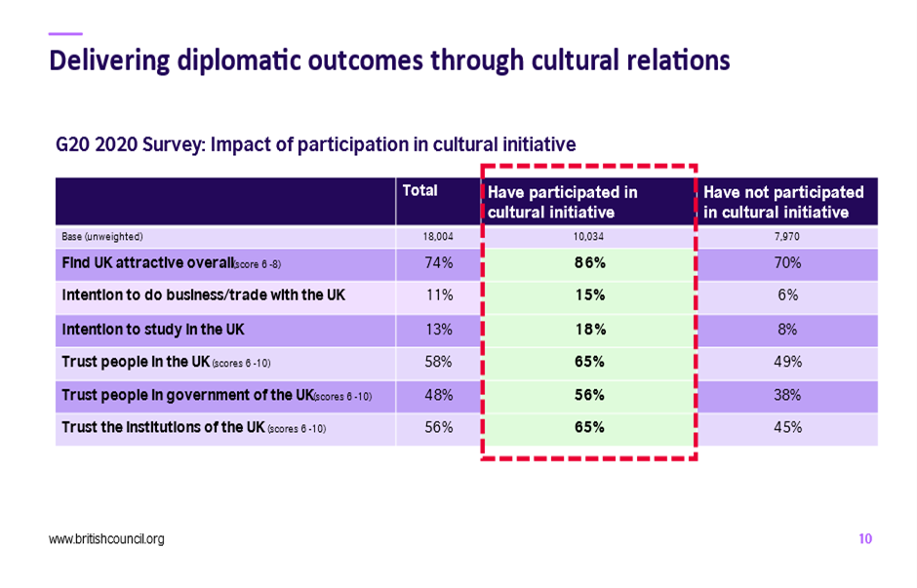

Soft power is a process rather than an outcome, Nye (2008) explains that soft power is concerned with the attractiveness of a nation – the business of inspiring others focused on intangible elements such as culture, political values and foreign policies. Cummings refers to soft power as: “the exchange of ideas, information, values, systems, traditions, beliefs, and other aspects of culture, with the intention of fostering mutual understanding.” (Cummings, 2003) Soft power is identified as a pull factor that depends on legitimate agenda setting, persuasion, the attractiveness of values, and the “impression of kindness, competence, or charisma” (Nye 2021, 6). Soft power enables events such as Eurovision to build trust, favourability, and attractiveness, that UK HMG can use to achieve tangible outcomes.
“The Eurovision Song Contest in variegated Europe can be seen as a tool of contemporary cultural diplomacy, a form of the “soft power… the ESC also represents a strong “soft power” resource – a way to get a point across through attracting rather than coercing.”
Soft power does not have to be a zero-sum game, and the creative industries can play a crucial role in supporting a soft power strategy based on mutuality and trust. Understanding the drivers of soft power has long been a priority of the British Council’s research programme. The British Council report ‘The value of trust report’ identified the qualities most strongly associated with trust in the people and government of the UK.
These were that the UK:
- was perceived as open and welcoming,
- has a free and fair justice system,
- world-leading arts and culture,
- had a government that treats everyone fairly,
- contributes its fair share to aid, and works,
- constructively with others around the world.
Openness was the single strongest driver of trust in people, followed by contribution to development and a free justice system. For trust in government, the state’s contribution to development was the most prominent driver, followed by works constructively with other governments and openness.
Further exploration of these drivers and elements of Soft Power are explored in the British Council report ‘Sources of soft power How perceptions determine the success of nations.’ For example, the report explored the impact of previous experience through tourism and consumption of arts and culture on perceptions of 20 qualities statements with young people based in 7 comparator countries: -“Culture provides a platform for engaging, sharing and understanding, it provides a safe space to convene, where trust can be built even in the face of geopolitical conflict. Critically, it is an expression of a people’s values.”
The impact of previous experience through tourism and consumption of arts and culture on perceptions of 20 qualities statements across 7 countries.

The Creative Industries, including arts and culture, operate at two levels: when culture is defined traditionally as arts – as part of the toolkit for cultural diplomacy in support of national interests, aligned with foreign policy. When culture is defined widely as the characteristics and knowledge of a particular group of people, encompassing language, religion, cuisine, social habits, music, and arts, it is the key element of cultural relations in support of long-term engagement. As Borić and Kapor (2017) note:-
For example, UK Music found “The cultural importance of British music abroad is widely recognised by the UK public. In our poll, we found that 59% of those we spoke to agreed that the UK’s music industry helps improve our reputation abroad and 53% of those we spoke to agreed that the UK’s music industry punches above our weight internationally.”
Due to the limited number of international large scale cultural events, as compared to large scale international sport events, there is currently limited evidence of the soft power enabled benefits of large scale international cultural events. One example is the external evaluation of the London Cultural Olympiad 2012, which found: -
“The Cultural Olympiad and London 2012 Festival helped enhance the perception of Britain abroad with the UK’s overall rating in the Nations Brand Index going up one place in autumn 2012, reflecting significant rises in the rating of the UK’s sporting excellence, culture, natural beauty and tourism. The study found that over 170,000 events took place over the course of the Cultural Olympiad with over 40,000 artists involved from across the whole of the UK with some regions presenting as high a volume of activity as London.”
For further reading, please refer to the Reference Section of this brief.
3 Proposal Conditions and Contractual Requirements
This section of the RFP sets out the British Council’s contracting requirements, general policy requirements, and the general conditions relating to this procurement process (“Procurement Process”).
3.1 Contracting requirements
3.1.1 Contracting authority: the British Council which includes any other companies and organisations that control or are controlled by the British Council from time to time (see: http://www.britishcouncil.org/organisation/structure/status).
3.1.3 Duration: This contact will run from March 2023 to February 2024 ith an option for an extension for up to an additional 3 months.
3.1.4 Contractual terms: As set out at Annex 1 (“Contract”). By submitting a Proposal, you are agreeing to be bound by the terms of this RFP and the Contract without further negotiation or amendment. Once the Contract is awarded, there will be no changes allowed to the Contract (except in accordance with the provisions of the Contract). Any clarification questions in relation to any aspect of this Procurement Process and the associated documentation should be submitted in accordance with the process set out in paragraph 12 (Clarification Requests). Only changes which relate to the correction of ambiguity or manifest error in relation to the terms of the Contract will be considered and, if necessary, the British Council may, when issuing its response to clarification questions, reissue Annex 1 to reflect such changes. Any proposed amendments received from a potential supplier as part of its Proposal shall entitle the British Council to reject that Proposal and to disqualify that potential supplier from this Procurement Process.
3.2 General Policy Requirements
3.2.1 By submitting a Proposal, you confirm that you will, and that you will ensure that any consortium members and/or subcontractors will, comply with all applicable laws, codes of practice, statutory guidance and applicable British Council policies relevant to the goods and/or services being supplied. All relevant British Council policies that suppliers are expected to comply with can be found on the British Council website (https://www.britishcouncil.org/organisation/transparency/policies).
3.3 General Proposal conditions (“Proposal Conditions”)
3.3.1 Application of these Proposal Conditions – In participating in this Procurement Process and/or by submitting a Proposal it will be implied that you accept and will be bound by all the provisions of this RFP and its Annexes. Accordingly, Proposals should be made on the basis of and strictly in accordance with the requirements of this RFP.
3.3.2 Third party verifications – Your Proposal is submitted on the basis that you consent to the British Council carrying out all necessary actions to verify the information that you have provided, and the analysis of your Proposal being undertaken by one or more third parties commissioned by the British Council for such purposes.
3.3.3 Information provided to potential suppliers – Information that is supplied as part of this Procurement Process is supplied in good faith. The information contained in the RFP and the supporting documents and in any related written or oral communication is believed to be correct at the time of issue. No liability (save for fraudulent misrepresentation) is accepted for its accuracy, adequacy or completeness and no warranty is given as such.
3.3.4 Potential suppliers to make their own enquires – You are responsible for analysing and reviewing all information provided to you as part of this Procurement Process and for forming your own opinions and seeking advice as you consider appropriate. The clarification process set out in paragraph 12 should be used for any queries in relation to this Procurement Process.
3.3.5 Amendments to the RFP – At any time prior to the Response Deadline, the British Council may amend the RFP and if appropriate, the Response Deadline shall, at the discretion of the British Council, be extended.
3.3.6 Compliance of Proposal – Any goods and/or services offered should be on the basis of and strictly in accordance with the RFP (including, without limitation, any specification of the British Council’s requirements, these Proposal Conditions and the Contract) and all other documents and any clarifications or updates issued by the British Council as part of this Procurement Process.
3.3.7 Compliance with the terms of the Contract – The successful supplier must comply with the Contract as set out in Annex 1 without any amendment (save as described in paragraph 3.1.4). .
3.3.8 Format of Proposal – Proposals must comprise the relevant documents as detailed by the British Council in Annex 2 (Supplier Proposal) completed in accordance with relevant all instructions. Any documents requested by the British Council must be completed in full. It is important that you read the RFP carefully before completing and submitting your Proposal.
3.3.9 Modifications to Proposals once submitted – You may modify your Proposal prior to the Response Deadline by giving written notice to the British Council. Any modification should be clear and submitted as a completely new Proposal in accordance with Annex 2 (Supplier Proposal) and these Proposal Conditions.
3.3.10 Disqualification – If you breach these Proposal Conditions, if there are any errors, omissions or material adverse changes relating to any information supplied by you at any stage in this Procurement Process, if any other circumstances set out in this RFP, and/or in any supporting documents, entitling the British Council to reject a Proposal apply and/or if you or your appointed advisers attempt:
- to inappropriately influence this Procurement Process or fix or set the price for goods or services;
- to enter into an arrangement with any other party that such party shall refrain from submitting a Proposal;
- to enter into any arrangement with any other party (other than another party that forms part of your consortium bid or is your proposed sub-contractor) as to the prices submitted;
- to collude in any other way;
- to engage in direct or indirect bribery or canvassing by you or your appointed advisers in relation to this Procurement Process; or
- to obtain information from any of the employees, agents or advisors of the British Council concerning this Procurement Process (other than as set out in these Proposal Conditions) or from another potential supplier or another Proposal,
the British Council shall be entitled to reject your Proposal in full and to disqualify you from this Procurement Process. Subject to paragraph 3.3.1 below, by participating in this Procurement Process you accept that the British Council shall have no liability to a disqualified potential supplier in these circumstances.
3.3.11 Proposal costs – You are responsible for obtaining all information necessary for preparation of your Proposal and for all costs and expenses incurred in preparation of the Proposal. Subject paragraph 3.3.15, you accept by your participation in this Procurement Process, including without limitation the submission of a Proposal, that you will not be entitled to claim from the British Council any costs, expenses or liabilities that you may incur in submitting a Proposal irrespective of whether or not your Proposal is successful.
3.3.12 Rights to cancel or vary this Procurement Process – Nothing in this Procurement Process will bind the British Council to enter into any contractual or other arrangement with you or any other potential supplier. It is intended that the remainder of this Procurement Process will take place in accordance with the provisions of this RFP, but the British Council reserves the right to terminate, amend or vary (to include, without limitation, in relation to any timescales or deadlines) this Procurement Process by notice in writing. Subject to paragraph 3.3.15, the British will have no liability for any losses, costs or expenses you incur as a result of such actions.
3.3.13 Consortium Members and sub-contractors – It is your responsibility to ensure that any staff, consortium members, sub-contractors and advisers abide by these Proposal Conditions and the requirements of this RFP.
3.3.14 Liability – Nothing in these Proposal Conditions is intended to exclude or limit the liability of the British Council in relation to fraud or in other circumstances where the British Council’s liability may not be limited under any applicable law.
4 Confidentiality and Information Governance
4.1 All information supplied to you by the British Council, including this RFP and all other documents relating to this Procurement Process, either in writing or orally, must be treated in confidence and not disclosed to any third party (save to your professional advisers, consortium members and/or sub-contractors strictly for the purposes only of helping you to participate in this Procurement Process and/or prepare your Proposal) unless the information is already in the public domain or is required to be disclosed under any applicable laws.
4.2 You shall not disclose, copy or reproduce any of the information supplied to you as part of this Procurement Process other than for the purposes of preparing and submitting a Proposal. There must be no publicity by you regarding the Procurement Process or the future award of any contract unless the British Council has given express written consent to the relevant communication.
4.3 The British Council reserves the right to disclose all documents relating to this Procurement Process, including without limitation your Proposal, to any employee, third party agent, adviser or other third party involved in the Procurement Process in support of, and/or in collaboration with, the British Council. The British Council further reserves the right to publish the Contract once awarded and/or disclose information in connection with supplier performance under the Contract in accordance with any public sector transparency policies (as referred to below). By participating in this Procurement Process, you agree to such disclosure and/or publication by the British Council in accordance with such rights reserved by it under this paragraph.
4.4 The Freedom of Information Act 2000 (“FOIA”), EU General Data Protection Regulation (GDPR) 2015, the Environmental Information Regulations 2004 (“EIR”), and public sector transparency policies apply to the British Council (together the “Disclosure Obligations”).
4.5 You should be aware of the British Council’s obligations and responsibilities under the Disclosure Obligations to disclose information held by the British Council. Information provided by you in connection with this Procurement Process, or with any contract that may be awarded as a result of this exercise, may therefore have to be disclosed by the British Council under the Disclosure Obligations, unless the British Council decides that one of the statutory exemptions under the FOIA or the EIR applies.
5 Proposal Validity
5.1 Your Proposal must remain open for acceptance by the British Council for a period of 60 from the Response Deadline. A Proposal not valid for this period may be rejected by the British Council.
6 Payment and Invoicing
6.1 The British Council will pay correctly addressed and undisputed invoices within 30 days in accordance with the requirements of the Contract. Suppliers to the British Council must ensure comparable payment provisions apply to the payment of their sub-contractors and the sub-contractors of their sub-contractors. General requirements for an invoice for the British Council include:
- A description of the good/services supplied is included.
- The British Council Purchase Order number is included.
- It is sent electronically via email in PDF format to BC.Invoices@britishcouncil.org or by post to:
The British Council, Corporate Services – UK Hub Team, 1 Redman Place, Stratford, London E20 1JQ
The budget range for this commission is in the region of £100,000 including VAT (£83k plus VAT).
7 Specification
We are seeking to appoint an experienced research supplier that can demonstrate its capability, capacity and the ability to work at speed across a diverse range of partners and stakeholders to deliver this research commission over the next 6-7 months to respond to the research questions / areas of interest and sub-questions:

- Explore the role and impact of Eurovision within City Branding and Soft Power. Investigate how Eurovision supports host cities and nations international brand or soft power (as seen by broad populations, influencers and/or leaders in Europe and beyond). To explore whether Eurovision gives European nations, and cities, such as Liverpool, a reputation uplift based on the values/characteristics it embodies/showcases each year within the Europe region.

- Eurovision as a vehicle to developing shared values, mutual relationships during a time of conflict, developing a better understanding Eurovision’s role (or not) in crystalising shared values and/or coalescing around shared values across Europe? And its role in establishing or strengthening relationships in Europe at a time of conflict, based on mutual values and interests.

Research sub-questions
- International relations and whether Eurovision has an impact.

- To explore whether Eurovision gives European nations, and cities, in this case Liverpool, a reputation uplift based on the values/characteristics it embodies/showcases within the Europe region. Has the event been seen as being the UK hosts on behalf of Ukraine or if it’s seen solely as a Ukrainian Eurovision or a UK Eurovision?
- To develop a better understanding the soft power enabled effects of cultural events and the broadcasting cultural events as a vehicle to project the nations cultural values such as future visits to the UK as a result of seeing Eurovision, new business opportunities for UK figures as a result of the country or city being showcased in such a way.
- Which of a set list of ‘brands’ (UK / Liverpool / Eurovision / the BBC / UK Music) plays a pivotal role in adding credibility / generating trust amongst different constituencies when we talk about specific values, be them: inclusion, diversity, peace, internationalism, generosity, empowerment.
- Culture in conflict and peacebuilding and how Eurovision could play a contributing role?
- The narrative of the UK hosting on behalf of the Ukraine and what was learnt.

Research Methods
There are several challenges in measuring the effects of soft power and recent evaluation and research have explored taking an ecosystem / systems approach to evaluating soft power programmes . Yun argues that current soft power metrics, particularly the Soft Power 30, are problematic as they ‘[confuse] the distinction between means of soft power and outcomes of soft power’. Problematically, many of these metrics also conflate the concepts of ‘trust’ alongside others, such as ‘attractiveness’ or ‘likeability.
Through this research commission we propose using a combination of mixed method approach of qualitative and quantitative research methods: -
- Inception, scoping and design of the research approach ahead of Eurovision. This will involve working with partners such as DCMS, BBC, Liverpool City Council and the British Council to understand what benefits the UK hopes to achieve by hosting Eurovision.
- Using an international literature review explore the available current evidence base around the soft power enabled effects of major / large scale cultural events, please refer to the Reference Section of this brief for some examples.
- Using international focus groups tracking survey over the 6 months post Eurovision 2023, tracking the soft power halo effects of Eurovision 2023 across a series of targeted priority European countries (6/7 countries) which are agreed with the Eurovision Evaluation Steering Group with sufficient sample sizes allowing for drop off rates across the focus groups.This tracking survey would explore a list of agreed values/characteristics building on the thinking around the qualities identified in ‘The Value of Trust’ report and the impact of belonging to a ‘European Community’. a) To explore whether Eurovision gives European nations, and cities, in this case Liverpool, a reputation uplift based on the values/characteristics it embodies/showcases within the Europe region. With a set list of ‘brands’ (UK / Liverpool / Eurovision / the BBC / UK Music) exploring their role in adding credibility / generating trust amongst different constituencies when we talk about specific values, be them: inclusion, diversity, peace, internationalism, generosity, empowerment. Annex 4 to this brief provides an example of The British Council’s G20 Survey Questions which can provide a starting point in developing the questions for this tracking survey such as the G20 Survey Core Questions, Issues sets of questions and the Soft Power Qualities questions.
- Undertake a series of process tracking evaluation and case study interviews with organisers from across partner stakeholder organisations such as the BBC, DCMS and Liverpool City Council to explore the narrative of the UK hosting on behalf of the Ukraine and what was learnt.This work could also be linked to and draw on other international surveys, survey questions, survey approaches, such as the: -
- British Council’s G20 Survey including drawing on previous data collected in 2021 and 2022 on the Ukraine and also the planned Survey for 2023 which will go into the field around April 2023.
- The BBC Impact and Influence Research ;
- Eurovision Brand Impact Reporting, for example the Eurovision 2022 report https://confindustriaradiotv.it/wp-content/uploads/2022/08/EBU-MIS_Eurovision_Song_Contest_Brand_Impact_Report_2022_compressed.pdf which covers various topics such as the audience engagement across TV and Online, the press coverage, the performances of the ESC songs on music streaming platforms, the broader economic direct and indirect impact of the show and its contribution to society.
- Drawing on findings from the current external evaluation of the British Council’s UK Ukraine Season by In2Impact which will be available July 2023.
- Please refer to the Annex 4 for the survey questions used in the British Council G20 survey which can form the starter for the development of the survey questions for this commission such as the Core Questions, Issues sets of questions and the Soft Power Qualities questions.

Technical Advisory Group
As part of this research, we propose creating a small Technical Advisory Group to support the selected research team and to make links across other aspects of the Eurovision evaluation work, the proposed focus group questions and other relevant research, together with supporting the sharing of the findings from the research.

Reporting outputs from this research commission
By mid-June 2023 (see point 10 for further dates)
- First initial report with findings from the first focus group and a paper exploring ‘Eurovision as a vehicle to developing shared values, mutual relationships during a time of conflict’.

By January 2024 (ready for the Eurovision Host City handover to the next Host City in January 2024)
- Full findings and written report with
  - executive summary
  - summary slide deck including research design / methodology, sampling, and data collection methodology
  - a discussion of the research conclusions that are well substantiated by the evidence and data presented and are logically connected to research findings.
Research Ethics
All research activity must ensure that high professional standards are adhered to. The integrity of research activity is essential for the responsible practice of research.

This Policy should be followed alongside the British Council’s Code of Conduct and Global Policy framework – with particular reference to the Safeguarding policies for Children and Adults, Information Security and Management policy, the Equality, Diversity and Inclusion (EDI) policy and guidance, and their respective processes. It has been developed in line with the Concordat to Support Research Integrity and in consultation of other external research ethics guidelines, policies and documents.

- All policy requirements, costs and capacity for assuring ethics and good research practice must be
worked into research or programme plans (and any contract)
- Any conflict of interest must be declared
- Research must be conducted according to relevant and required legal and professional frameworks, obligations and standards, including the principles of the Concordat to Support Research Integrity
- All sources of ideas, data, information, text or other intellectual property must be comprehensively referenced (including previous British Council reports and digital sources including social media)
- The input of authors and other contributors to the research must be appropriately acknowledged
- Permission and agreement for a research output to be published should be obtained from all those listed as an author of the output
- All research involving human participants must adhere to the principles outlined below relating to informed consent and the right to anonymity
- All aspects of the research process should be culturally contextualised and aligned to British Council values and EDI principles – this includes the framing of research questions, objectives and outputs, methodology design and the selection of suppliers, partners and participants

For queries relating to this Policy, or about research ethics and good research practice more generally, contact the Research & Policy Insight team via the Head of Research at research.risk@britishcouncil.org

8 Mandatory Requirements / Constraints
8.1 As part of your Proposal, you must confirm that you meet the mandatory requirements / constraints, if any, as set out in the British Council’s specification forming part of this RFP. Failure to comply with any mandatory requirements or constraints shall entitle the British Council to reject a Proposal.
- Experience of researching / evaluating large scale international cultural events / programmes.
- Knowledge and experience of research methods around soft power and cultural relations.
- The ability to work at speed with a diverse group of partners and stakeholders
9 Key background documents
9.1 Further relevant background documents / information may be provided to potential suppliers as an Annex to this RFP and/or by way of the issue of additional documents / links to additional information / documents. Please view list of Annexes at the end of this document.
10 Timescales
10.1 Subject to any changes notified to potential suppliers by the British Council in accordance with the Proposal Conditions, the intended timescales applicable to this Procurement Process are:

Action | Time
Concept Note Agreed by Eurovision Evaluation Steering Group | 21st February 2023
Request for Research Proposals Go Live via the British Council’s InTend portal | 23rd February 2023
Deadline for Clarification Questions via InTend portal | 1st March 2023
Closing Date for Proposals | 4pm UK time 16th March 2023
Selection of research supplier | 20th March to 24th March
Appointment of Research Supplier | 27th March 2023
Research Supplier starts work | 1st April 2023
Research Inception Period and pre-event interviews including inception meeting with the BBC, DCMS, GREAT and FCDO | 1st April to 13th May 2023
Post Eurovision 2023 first wave of focus groups | 13th May 2023 to 1st June 2023
First progress report | Mid-June 2023
Additional tracking focus groups | June to December 2023
Final report | January 2024

11 Instructions for Responding
11.1 The documents that must be submitted to form your Proposal are listed at Part 2 (Submission Checklist) of Annex 2 (Supplier Proposal) to this RFP. All documents required as part of your Proposal should be submitted to https://in-tendhost.co.uk/britishcouncil by the Response Deadline, as set out in the Timescales section of this RFP.
11.2 The following requirements should be complied with when submitting your Proposal in response to this RFP:
- Please ensure that you send your submission in good time to prevent issues with technology – late Proposals may be rejected by the British Council.
- Do not submit any additional supporting documentation with your Proposal except where specifically requested to do so. PDF, JPG, PPT, Word and Excel formats can be used for any additional supporting documentation (other formats should not be used without the prior written approval of the British Council).
- All attachments/supporting documentation should be provided separately to your main Proposal document, clearly labelled and cross-referenced to the Proposal as relevant.
- If you submit a generic policy / document you must indicate the page and paragraph reference that is relevant to a particular part of your Proposal.
- Unless otherwise stated as part of this RFP or its Annexes, all Proposals should be in the format of the relevant British Council requirement with your response to that requirement inserted underneath.
- Where supporting evidence is requested as ‘or equivalent’ you must demonstrate such equivalence as part of your Proposal.
- Any deliberate alteration of a British Council requirement as part of your Proposal will invalidate your Proposal to that requirement and for evaluation purposes you shall be deemed not to have responded to that particular requirement.
- Responses should be concise, unambiguous, and should directly address the requirement stated.
- Your Proposal to the RFP requirements and pricing will be incorporated into the Contract, as appropriate.
12 Clarification Requests
12.1 All clarification requests should be submitted the British Council’s e-Tendering portal hosted at https://in-tendhost.co.uk/britishcouncil by the Clarification Deadline, as set out in the Timescales section of this RFP. The British Council is under no obligation to respond to clarification requests and will response if the question is appropriate and received before the Clarification Deadline.
12.2 Any clarification requests should clearly reference the appropriate paragraph in the RFP documentation and, to the extent possible, should be aggregated rather than sent individually.
12.3 The British Council reserves the right to issue any clarification request made by you, and the response, to all potential suppliers unless you expressly require it to be kept confidential at the time the request is made. If the British Council considers the contents of the request not to be confidential, it will inform you and you will have the opportunity to withdraw the clarification query prior to the British Council responding to all potential suppliers.
12.4 The British Council may at any time request further information from potential suppliers to verify or clarify any aspects of their Proposal or other information they may have provided. Should you not provide supplementary information or clarifications to the British Council by any deadline notified to you, your Proposal may be rejected in full and you may be disqualified from this Procurement Process.
13 Evaluation Criteria
13.1 You will have your Proposal evaluated as set out below:
Stage 1: Proposals will be checked to ensure that they have been completed correctly and all necessary information has been provided. responses correctly completed with all relevant information being provided and all mandatory requirements as outlined in Section 8 met will proceed to Stage 2. Any Proposal not correctly completed in accordance with the requirements of this RFP and/or containing omissions may be rejected at this point. Where a Proposal is rejected at this point it will automatically be disqualified and will not be further evaluated.
↓
Stage 2: If a bidder succeeds in passing Stages 1 of the evaluation, then it will have its Proposal evaluated in accordance with the evaluation methodology set out below.
13.2 Award Criteria – Responses from potential suppliers will be assessed to determine the most economically advantages proposal using the following criteria and weightings and will be assessed entirely on your response submitted:

Criteria | Weighting
Social Value | 10%
Quality | 30%
Methodology and Approach | 40%
Commercial | 20%

13.3 Scoring Model – Proposals will be subject to an initial review at the start of Stage 2 of the evaluation process. Any Proposals not meeting mandatory requirements or constraints (if any) will be rejected in full at this point and will not be assessed or scored further. Proposals not so rejected will be scored by an evaluation panel appointed by the British Council for all criteria other than Commercial using the following scoring model:

Points | Interpretation
10 | Excellent – Overall the response demonstrates that the bidder meets all areas of the requirement and provides all of the areas evidence requested in the level of detail requested. This, therefore, is a detailed excellent response that meets all aspects of the requirement leaving no ambiguity as to whether the bidder can meet the requirement.
7 | Good – Overall the response demonstrates that the bidder meets all areas of the requirement and provides all of the areas of evidence requested, but contains some trivial omissions in relation to the level of detail requested in terms of either the response or the evidence. This, therefore, is a good response that meets all aspects of the requirement with only a trivial level ambiguity due the bidders failure to provide all information at the level of detail requested.
5 | Adequate – Overall the response demonstrates that the bidder meets all areas of the requirement, but not all of the areas of evidence requested have been provided. This, therefore, is an adequate response, but with some limited ambiguity as to whether the bidder can meet the requirement due to the bidder’s failure to provide all of the evidence requested.
3 | Poor – The response does not demonstrate that the bidder meets the requirement in one or more areas. This, therefore, is a poor response with significant ambiguity as to whether the bidder can meet the requirement due to the failure by the bidder to show that it meets one or more areas of the requirement.
0 | Unacceptable – The response is non-compliant with the requirements of the RFP and/or no response has been provided.

13.4 Commercial Evaluation – Your “Overall Price” (as calculated in accordance with requirements of Annex 3 (Pricing Approach) for the goods and/or services will be evaluated by the evaluation panel for the purposes of the commercial evaluation, further information on this approach may be available in Annex 3. In the event that any prices are expressed as being subject to any pricing assumptions, qualifications or indexation not provided for by the British Council as part of the pricing approach, the British Council may reject the full Proposal at this point. The British Council may also reject any Proposal where the Overall Price for the goods and/or services is considered by the British Council to be abnormally low following the relevant processes set out under the procurement rules. A maximum offer score of 10 will be awarded to the Proposal offering the lowest “Overall Price”. Other Proposals will be awarded a mark by application of the following formula: (Lowest Overall Price/Overall Price being evaluated) x 10 (rounded to two decimal places) = commercial score.
13.5 Moderation and application of weightings – The evaluation panel appointed for this Procurement Process will meet to agree and moderate scores for each award criteria. Final scores in terms of a percentage of the overall Proposal score will be obtained by applying the relevant weighting factors set out as part of the award criteria table above. The percentage scores for each award criteria will be amalgamated to give a percentage score out of 100.
13.6 The Winning Proposal(s) - The winning Proposal shall be the Proposal scoring the highest percentage score out of 100 when applying the above evaluation methodology, which is also supported by any required verification evidence (to include, without limitation, any updated information)] obtained by the Authority relating to any self-certification or other requirements referred to at any time in this Procurement Process.

List of Annexes forming part of this RFP (issued as separate documents):
Annex 1 – Terms and Conditions of Contract
Annex 2 – Supplier Proposal
Annex 3 – Pricing Approach
Annex 4 – Example of British Council G20 Survey Questions

References
BBC (2022) The impact and influence of the BBC https://www.bbc.co.uk/aboutthebbc/documents/research-the-impact-and-influence-of-the-bbc.pdf
Bekcan, Umut and Pınar Uz Hançarlı. (2021) “Evaluation of Eurovision Song Contest as a Cultural Impact Tool.” Journal of History Culture and Art Research (2021).
Borić, Zrinka, and Ana Radović Kapor. "The European Song Contest as a tool of cultural diplomacy." Zbornik sveučilišta Libertas 1.1-2 (2017): 225-240.
Birmingham Festivals 2022 International Collaborations Evaluation Report https://resources.cwg-qbr.pulselive.com/qbr-commonwealth-games/document/2023/01/16/50b99fb8-3794-4d51-922d-1aa879f707ac/7.International-Collaborations-Evaluation.pdf
British Council (2018) The Cultural Value Project Cultural Relations in ‘Societies in Transition’. London https://www.hertieschool.org/fileadmin/2_Research/2_Research_directory/Research_projects/Cultural_Value_Project/CVP_Joint__Report_2018.pdf
British Council (2018) The Value of Trust. London https://www.britishcouncil.org/sites/default/files/the_value_of_trust.pdf
British Council (2019) The Art of Peace. London. https://www.britishcouncil.org/research-policy-insight/insight-articles/art-of-peace
British Council (2020a) Soft Power Today Measuring the Influences and Effects, London https://www.cultureinexternalrelations.eu/downloader/download-file?file=2018/07/3418_bc_edinburgh_university_soft_power_report_03b.pdf
British Council (2020b) The sources of soft power: How perceptions determine the success of nations. London https://www.britishcouncil.org/sites/default/files/sources-soft-power-report-perceptions-success.pdf
British Council (2021) Soft power and cultural relations in a time of crisis. London https://www.britishcouncil.org/research-policy-insight/policy-reports/soft-power-cultural-relations-crisis
British Council (2022) Trust in international relations, public diplomacy and soft power. London https://www.britishcouncil.org/sites/default/files/trust_in_international_relations_public_diplomacy_and_soft_power.pdf
British Council (2023) Soft power and cultural relations: a comparative analysis, London https://www.britishcouncil.org/sites/default/files/soft_power_and_cultural_relations_a_comparative_analysis_.pdf
Carminati, D. (2021) ‘Contextualizing Soft Power’s Analysis: The Value of Attractive National Features.’ E-International Relations (2021).
Carniel, J. (2019). Nation Branding, Cultural Relations and Cultural Diplomacy at Eurovision: Between Australia and Europe. In: Kalman, J., Wellings, B., Jacotine, K. (eds)
Core Cities (2021) Soft Power of UK Core Cities https://www.corecities.com/sites/default/files/field/attachment/21.10.21_Core%20Cities_Soft%20Power_Pages%20001.pdf
Cummings, Milton C. (2003). Cultural Diplomacy and the United States Government: A Survey, Washington, D.C: Center for Arts and Culture
Eurovision Song Contest Brand Impact Report 2022 https://confindustriaradiotv.it/wp-content/uploads/2022/08/EBU-MIS_Eurovision_Song_Contest_Brand_Impact_Report_2022_compressed.pdf
Gallarotti G. ‘Soft Power: what it is, why it´s important, and the conditions for its effective use.’ Journal of Political Power 4, no. 1 (2011): 25-47
García, B (2010) Media Impact Assessment (part II): Evolving press and broadcast narratives on Liverpool from 1996 to 2009
Gauja, A (2019) ‘The Politics of Diversity and Participation’, in C Hay and J Carniel (eds) Eurovision and Australia: Interdisiplinary Perspectives from Down Under, 33–55. Cham: Palgrave Macmillan.
Grous, A. (2021). Eurovisions: Identity and the International Politics of the Eurovision Song Contest since 1956. European Journal of Communication, 36(4), 424–428. https://doi.org/10.1177/02673231211029594
Hill, C. & Beadle, S. Art of Attraction. Soft Power and the UK´s Role in the World. London: The British Academy, 2014.
Impacts 08 – Langen & Garcia (May 2009) Measuring Impacts of Cultural Events.
Impacts 08 London 2012 Cultural Olympiad Evaluation https://news.liverpool.ac.uk/2013/04/25/cultural-olympiad-reinforces-britains-reputation-as-a-world-leader-in-culture/
Jordan, Paul. 2014. The Modern Fairy Tale: Nation Branding, National Identity and the Eurovision Song Contest in Estonia. University of Tartu Press.
Langen, F. and Garcia, B. (2008) ‘Measuring the Impact of Major Cultural Events: A Literature Review’, Arts Research Digest, 44: 1-7.
Liverpool City Region Culture and Internationalism Research (2018) https://www.liverpoolcityregion-ca.gov.uk/wp-content/uploads/Liverpool-City-Region-Culture-Internationalism-Research-Report-FINAL-2.pdf
Pesenti, Marina. (2020) Cultural Revival and Social Transformation in Ukraine: The role of culture and the arts in supporting post-Euromaidan resilience. Chatham House. London https://www.chathamhouse.org/2020/11/cultural-revival-and-social-transformation-ukraine
McPherson, G., McGillivray, D., Mamattah, S., Cox, T., & Norrman, K. E. (2017). Arts, Culture and Soft Power: Developing an Evidence Base. University of the West of Scotland.
Melissen, Jan. (2005) The New Public Diplomacy – Soft Power in International Relations Palgrave Macmillan, 2005.
Nye, Joseph S. (1990) “Soft Power.” Foreign policy, no. 80 (1990): 153–71.
Nye Jr, Joseph S. “Public Diplomacy and Soft Power.” The annals of the American academy of political and social science 616, no. 1 (2008): 94–109.
Nye, Joseph S. (2021): Soft power: the evolution of a concept, Journal of Political Power, DOI: 10.1080/2158379X.2021.1879572
OECD (2017), OECD Guidelines on Measuring Trust, OECD Publishing, Paris. http://dx.doi.org/10.1787/9789264278219-en
STATLER, K. C. (2012). The Sound of Musical Diplomacy. Diplomatic History, 36(1), 71–75. http://www.jstor.org/stable/44376137
Snow, Nancy, and Nicholas J Cull. (2020) Routledge Handbook of Public Diplomacy. Routledge, 2020.
Thomas, I. (2020) Building an Impact Evaluation Toolbox based on an Arts and Soft Power Ecosystem, Centre for Public Diplomacy, University of Southern California.
Vuving, Alexander. (2019) “How Soft Power Works.” Available at SSRN 1466220 (2009).
Wilken, L 2019, The Eurovision Song Contest as cultural diplomacy during the Cold War: transmitting western attractiveness. in OJM Garcia & R Magnusdottir (eds), Machineries of persuasion: European soft power and public diplomacy during the cold war. De Gruyter, Berlin, Rethinking the cold war, no. 3, pp. 171-190.
Yun, Seong-Hun. (2018) “An Overdue Critical Look at Soft Power Measurement: The Construct Validity of the Soft Power 30 in Focus.” Journal of International and Area Studies 25 (2018).
UK Music The Impact of The Music Industry https://www.ukmusic.org/wp-content/uploads/2022/05/This-Is-Music-2021-The-Impact-of-the-Music-Industry.pdf
Ukrainian Institute/Cultural Relations Platform. Cultural relations in the New Normal, 2021, https://cultureactioneurope.org/knowledge/cultural-relations-in-the-new-normal/

https://www.britishcouncil.org/sites/default/files/lit_review_short_working_paper_final_final.pdf
In2Impact (2019) Cultural Relations – Evidence of Impact
In2Impact Evidence of Cultural Relations
For more on the concept of Soft Power please refer to Joseph S. Nye (2021): Soft power: the evolution of a concept, Journal of Political Power, DOI: 10.1080/2158379X.2021.1879572
Policy and Evidence Centre for the Creative Industries submission to Promoting Britain abroad - Digital, Culture, Media and Sport Committee (2022)
https://www.britishcouncil.org/sites/default/files/the_value_of_trust.pdf also refer to British Council (2022) Trust in international relations, public diplomacy and soft power. London and the Edelman Trust Barometer 2023.
https://www.britishcouncil.org/sites/default/files/sources-soft-power-report-perceptions-success.pdf
https://www.britishcouncil.org/sites/default/files/sources-soft-power-report-perceptions-success.pdf
The Creative Industries were defined in the Government’s 2001 Creative Industries Mapping Document as “those industries which have their origin in individual creativity, skill and talent and which have a potential for wealth and job creation through the generation and exploitation of intellectual property”
https://www.ukmusic.org/wp-content/uploads/2022/05/This-Is-Music-2021-The-Impact-of-the-Music-Industry.pdf
https://news.liverpool.ac.uk/2013/04/25/cultural-olympiad-reinforces-britains-reputation-as-a-world-leader-in-culture/
Sample Approach: at least 1000 per country aiming to represent either the total population or the online population of the country.
https://www.betterevaluation.org/methods-approaches/methods/process-tracing
https://www.britishcouncil.org/research-policy-insight/policy-reports/global-perceptions-survey-2021 IpsosMORI interviewed a sample of 20,612 adults aged 18-34 across 19 countries. The data has been weighted for each individual country to the known offline population proportions for age within gender, and each country has been given equal weighting within the G20 dataset.
https://www.bbc.co.uk/aboutthebbc/documents/research-the-impact-and-influence-of-the-bbc.pdf
https://www.britishcouncil.org.ua/en/programmes/arts/uk-ukraine-season-of-culture

